LAB NO 1: CREATING TABLE USING ORACLE USER INTERFACE

Create Table:
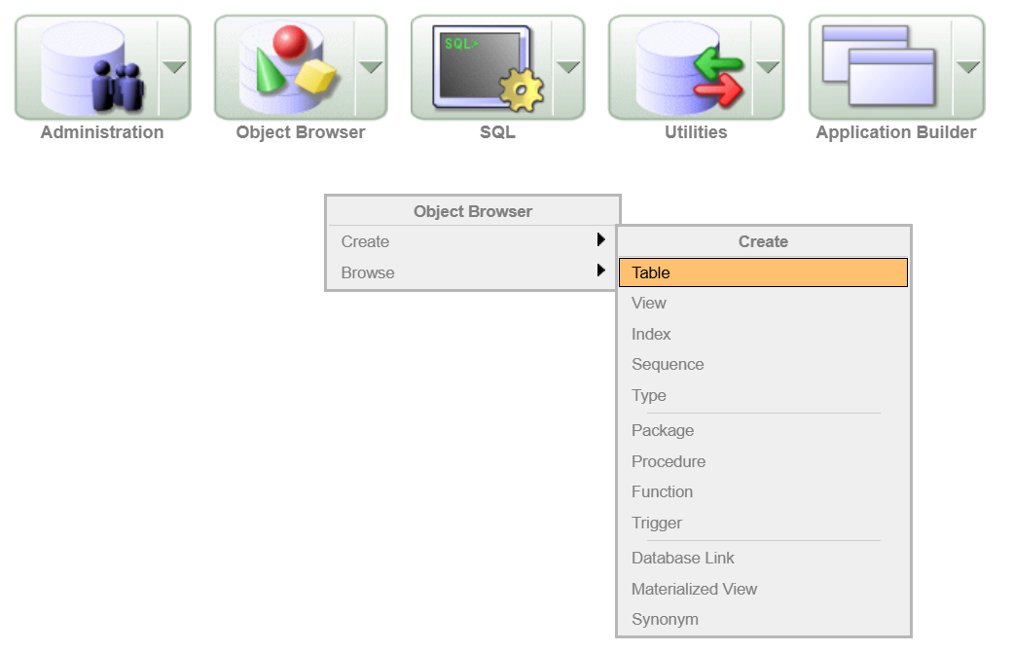
Figure 1: Creating a table by selecting “Object Browser” > “Create” > “Table”

Add Columns:
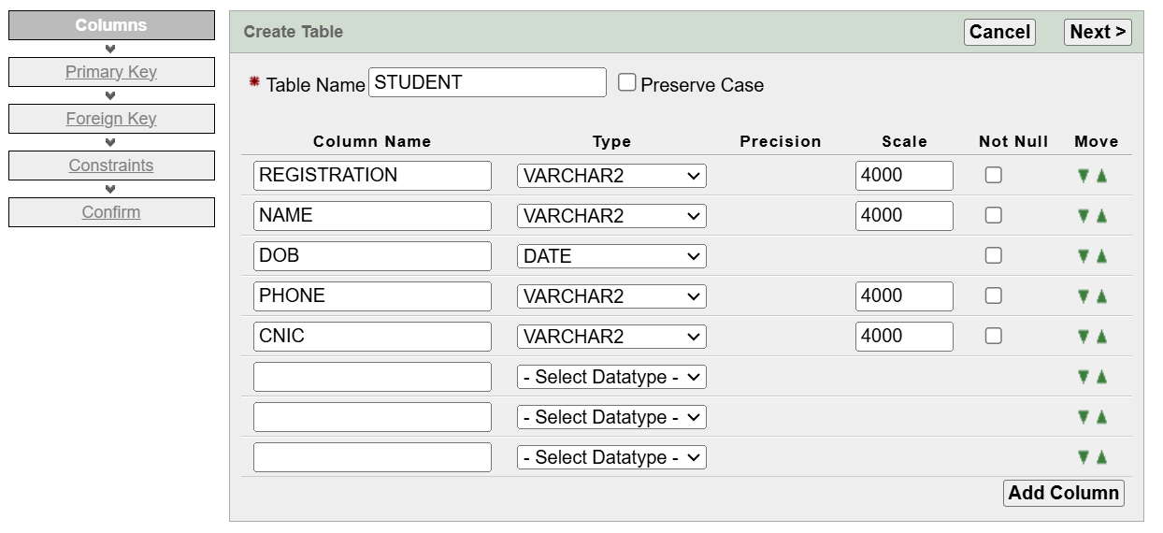
Figure 2: Creating the "Students" entity with attributes: Registration Number, Name, Date of Birth, and Phone/Cell Number.

Primary Key:
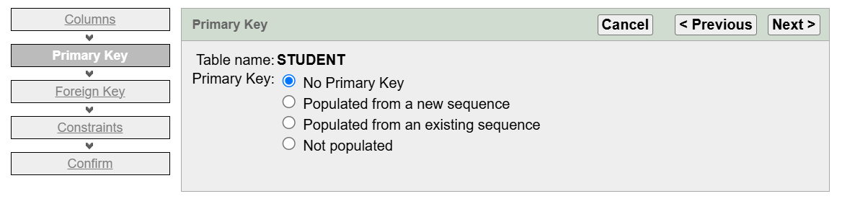
Figure 3: Primary Key Selection for STUDENT Table

Foreign Key:
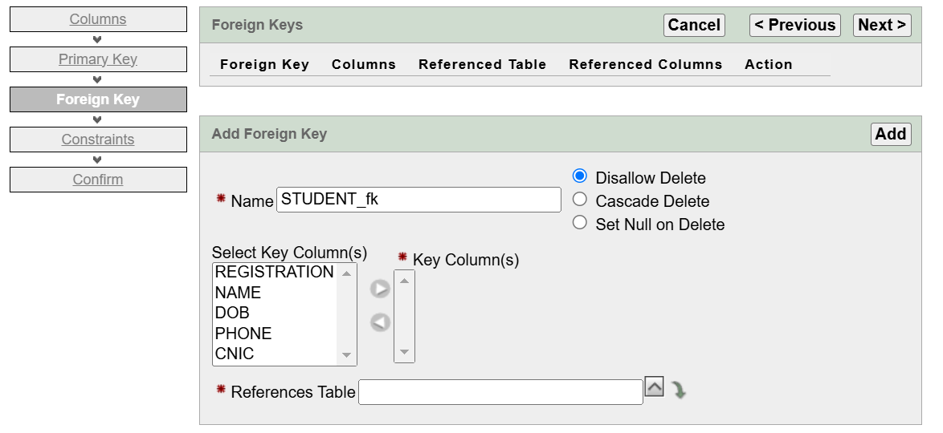
Figure 4: Foreign Key Configuration for STUDENT Table

Constraints:
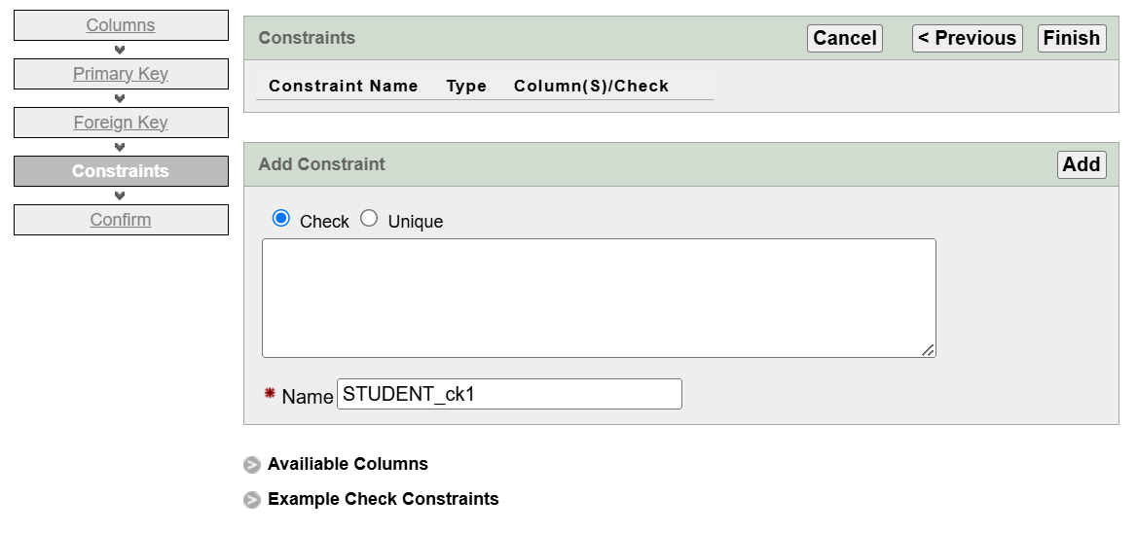
Figure 5: Constraints Configuration for STUDENT Table

Confirm:
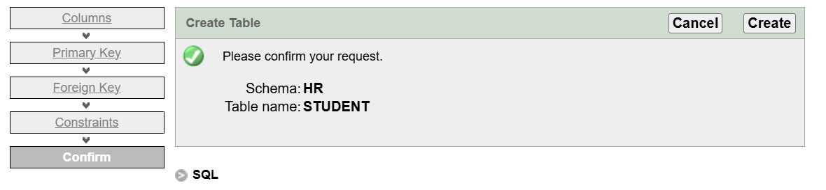
Figure 6: Table Creation Confirmation for STUDENT Table

Table Schema:
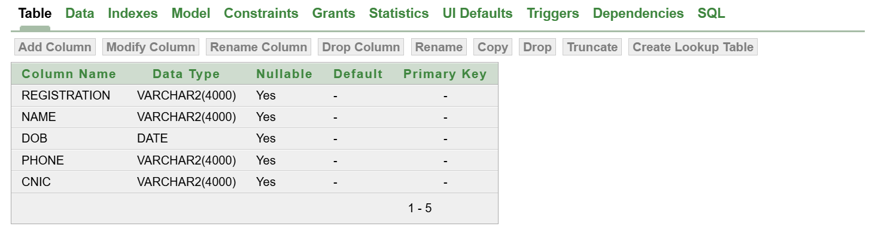
Figure 7: Table Structure of STUDENT Table

LAB NO 2: CREATING TABLE USING DDL COMMAND

Create Table Using SQL Command:
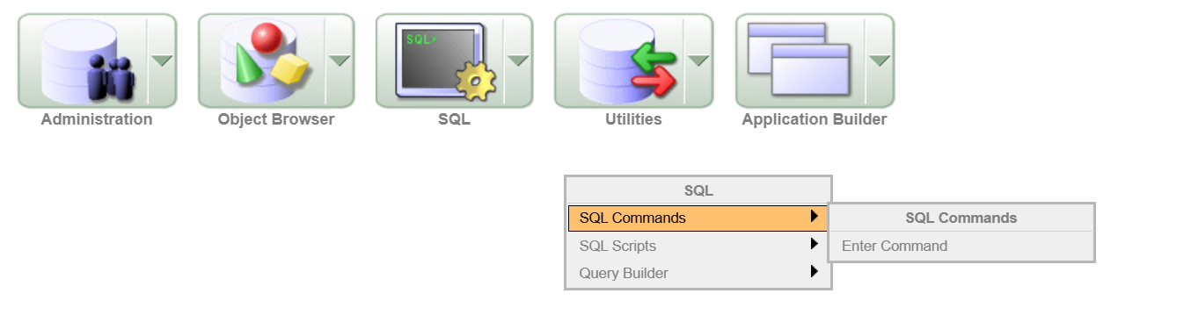
Figure 8: SQL Command Interface in Database Management System

Enter Commands:

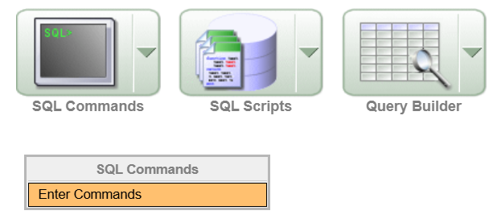
Figure 9: SQL Commands Interface

Task No 1:
Query:
CREATE TABLE "TUF_STUDENTS"
("STD_ID" VARCHAR2(5),
"STD_NAME" VARCHAR2(10),
"STD_FNAME" VARCHAR2(10),
"STD_DOB" DATE,
"STD_EMAIL" VARCHAR2(7),
"STD_ADRESS" VARCHAR2(10),
"STD_PHONE" NUMBER(11)
)
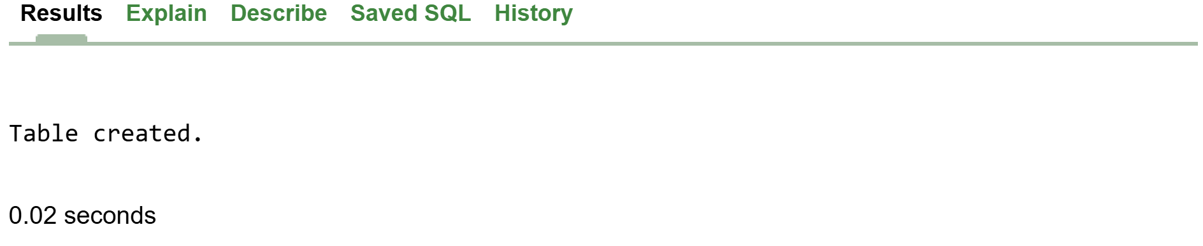
Figure 10: Table Creation Confirmation

DESCRIBE "TUF_STUDENTS";

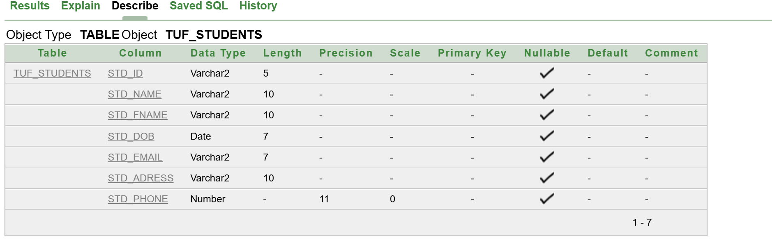
Figure 11: Table Structure of TUF_STUDENTS

Task No 2:
Query:
CREATE TABLE "GPTS" (
"CODING_GPT" VARCHAR2(10),
"MATH_GPT" VARCHAR2(10),
"NUMBER_OF_USERS" NUMBER(10),
"LAUNCH_DATE" DATE,
"RATING" FLOAT
);
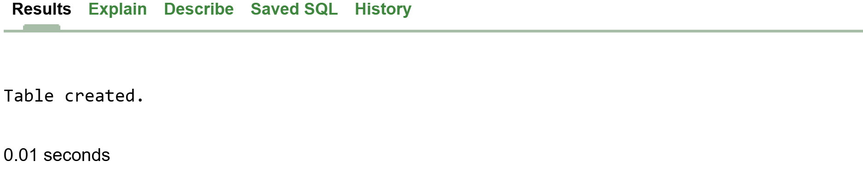
Figure 12: Table Creation Confirmation

DESCRIBE "TUF_STUDENTS";

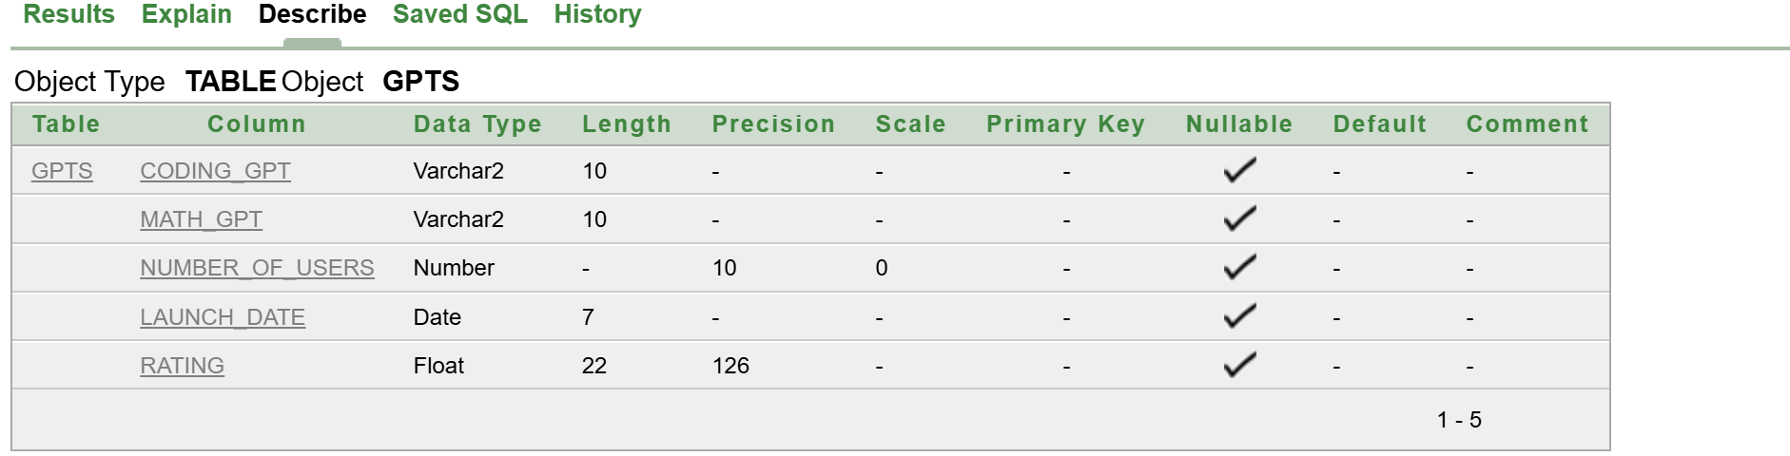
Figure 13: Table Structure of GPTS

Alter Table
ALTER TABLE TUF_STUDENTS
ADD STD_PERMANENT_ADRESS VARCHAR2(50);

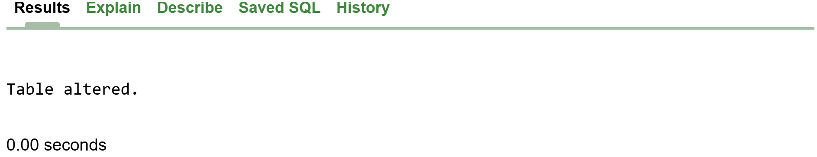
Figure 14: Table Alteration Confirmation
  - Table Structure After Adding One Column:
DESCRIBE "TUF_STUDENTS";
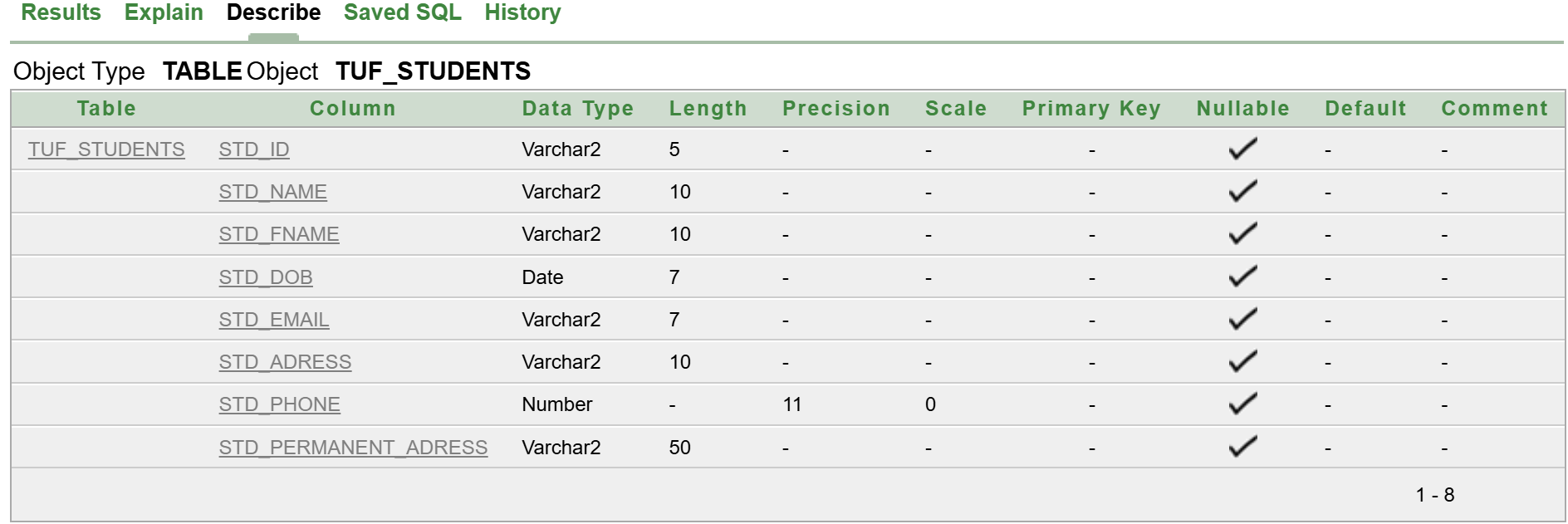
Figure 15: Updated Table Structure of TUF_STUDENTS
  - Rename Column:
Query:
ALTER TABLE TUF_STUDENTS
RENAME COLUMN STD_PERMANENT_ADRESS TO RELIGION;

Result:
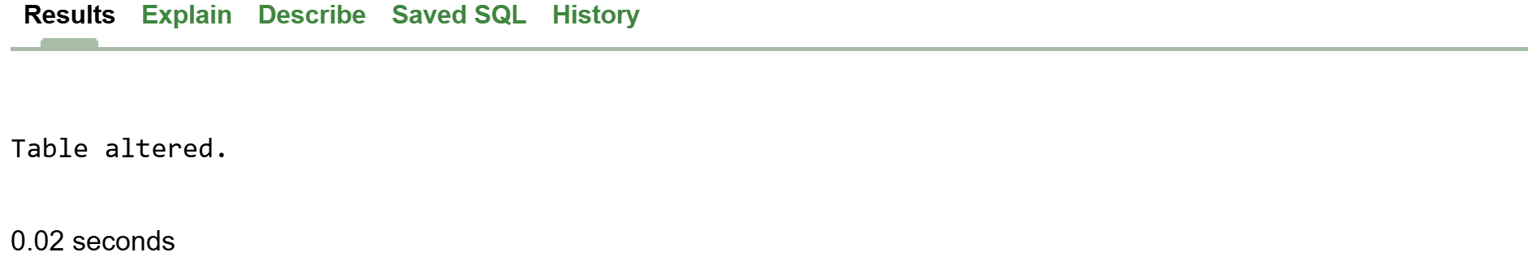
  - Modify Column:
Query:
ALTER TABLE TUF_STUDENTS
MODIFY RELIGION VARCHAR(10);

Result:
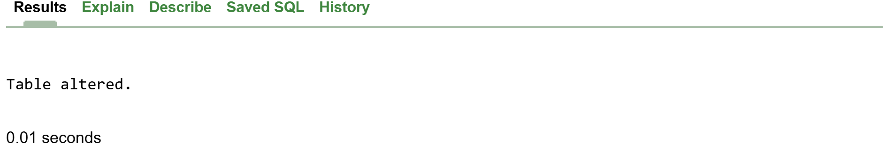

  - Delete Column
ALTER TABLE TUF_STUDENTS
DROP COLUMN GENDER;
Result:
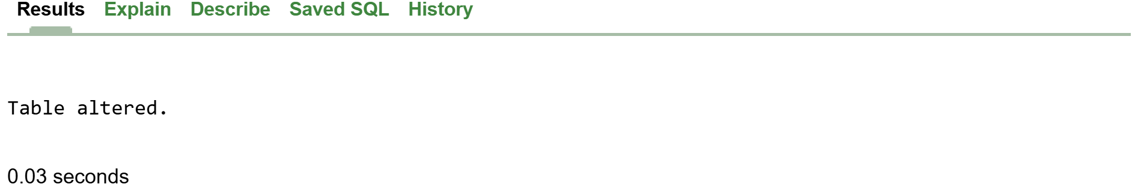

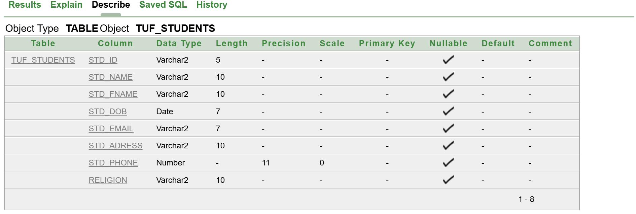
RENAME TABLE TUF_STUDENTS TO BSAI

DESCRIBE "BSAI";
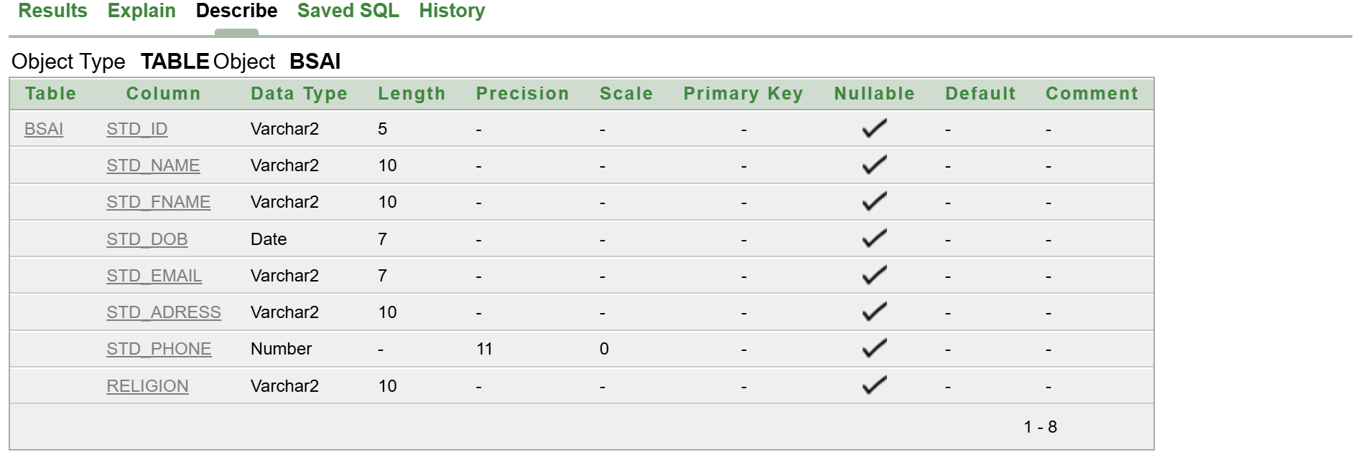

Task 3:
CREATE TABLE "LOGIN_PAGE" (
"ID" VARCHAR(10),
"USERNAME" VARCHAR2(10),
"PASSWORD" NUMBER(10)
);
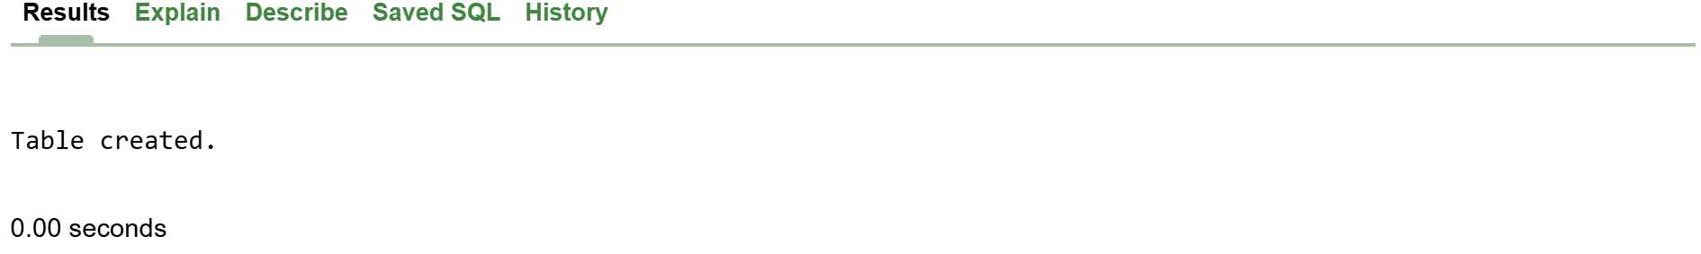
DESCRIBE "LOGIN_PAGE";

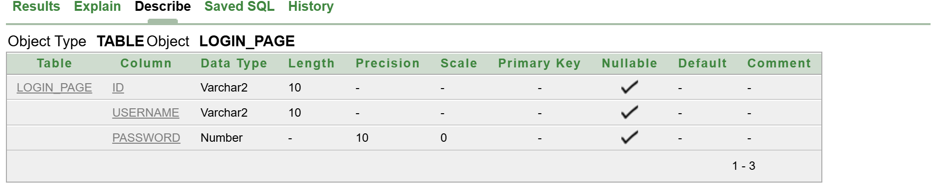

DROP TABLE "LOGIN_PAGE";
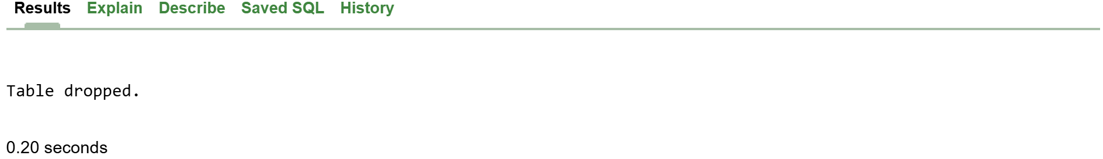

DESCRIBE "LOGIN_PAGE";
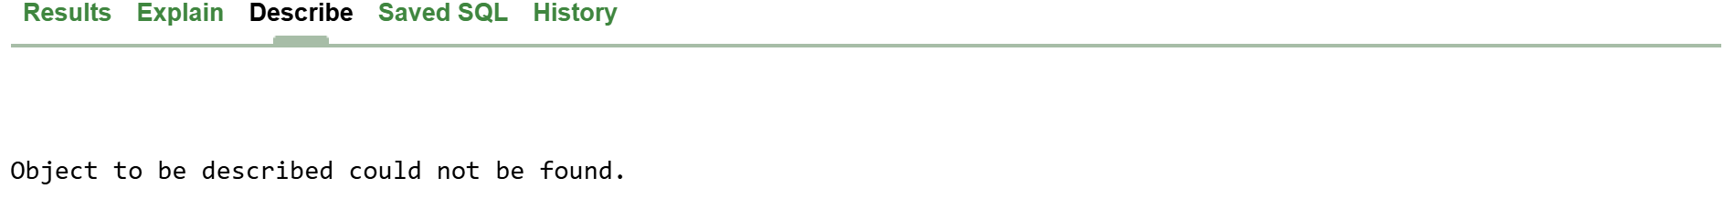
TRUNCATE TABLE STD_RESULT;
SELECT * FROM STD_RESULT;

LAB 3: INSERTING VALUES USING DML COMANDS
TASK #1
CREATE TABLE "STUDENT_RESULT"
( "STUDENT_ID" NUMBER(3,0) NOT NULL ENABLE,
"STUDENT_NAME" VARCHAR2(20),
"SUB_MARKS" NUMBER(5,0),
"SUB_GPA" NUMBER NOT NULL ENABLE,
"SUB_GRADE" CHAR(1),
"SUB_NAME" VARCHAR2(20)
)
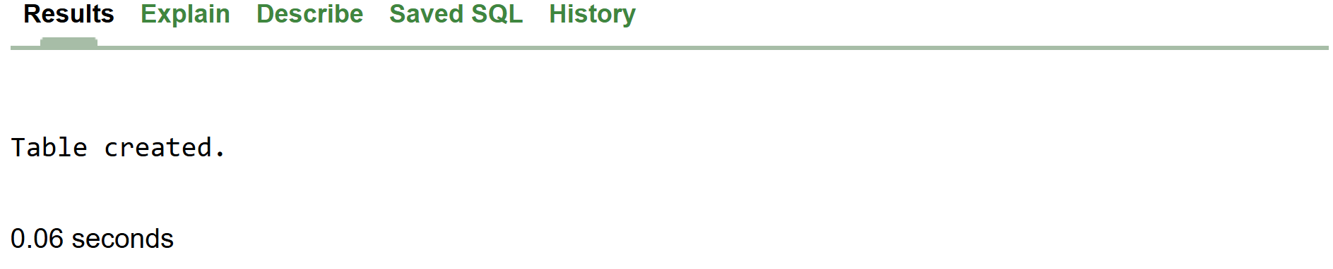

ALTER TABLE STUDENT_RESULT
ADD STUDENT_SEMESTER VARCHAR2(3)
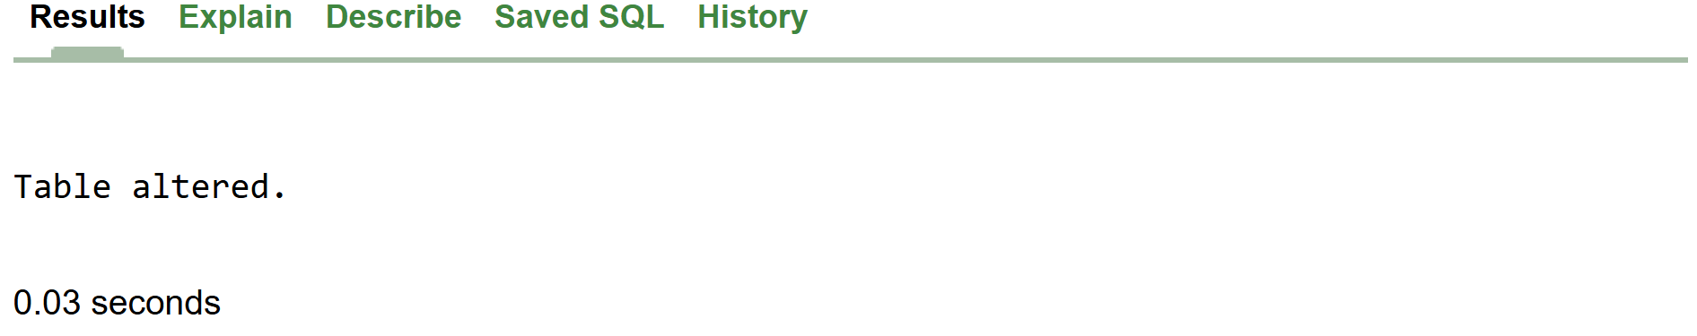

ALTER TABLE STUDENT_RESULT
RENAME COLUMN SUB_CGPA TO SUB_GPA
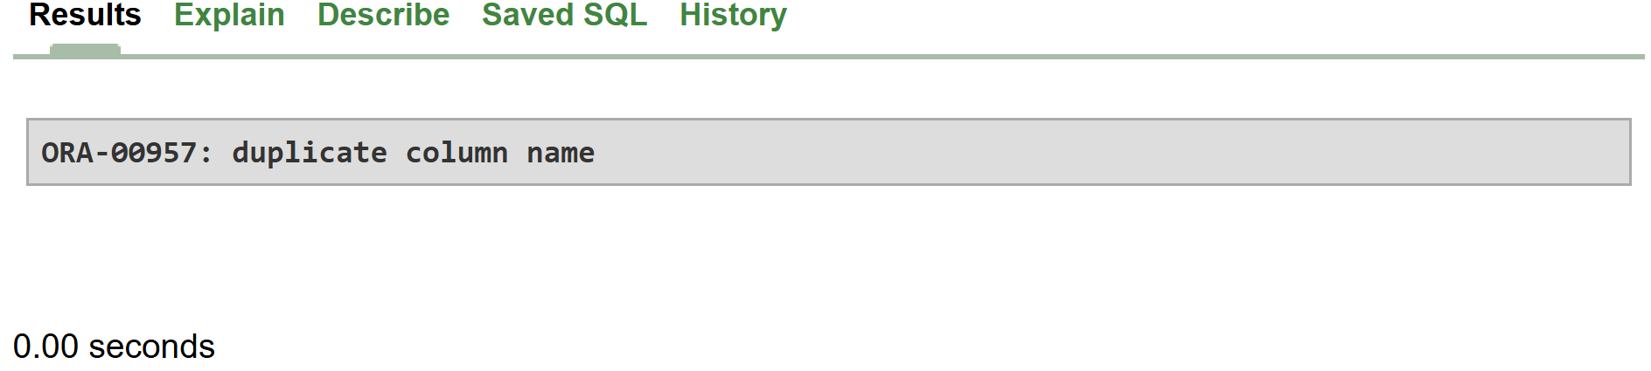
INSERT INTO STD_RESULT(STUDENT_ID, STUDENT_NAME, SUB_MARKS, SUB_GPA, SUB_GRADE, SUB_NAME)
VALUES (01,'ABC',65,3.8,'A','DB')
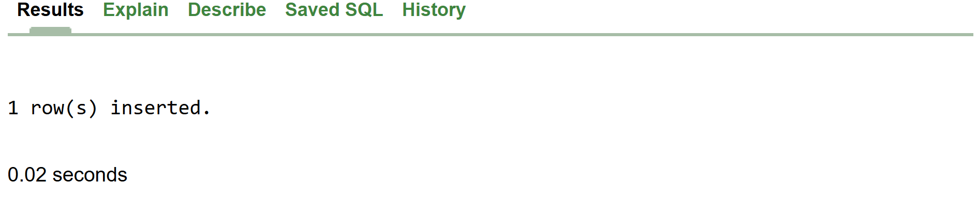
SELECT * FROM STD_RESULT;
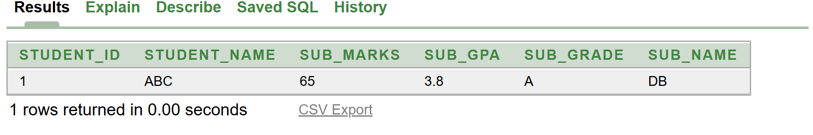
INSERT INTO STD_RESULT(STUDENT_ID, STUDENT_NAME, SUB_MARKS, SUB_GPA, SUB_GRADE, SUB_NAME)
VALUES (003,'JKL',59,3.9,'B','DB');
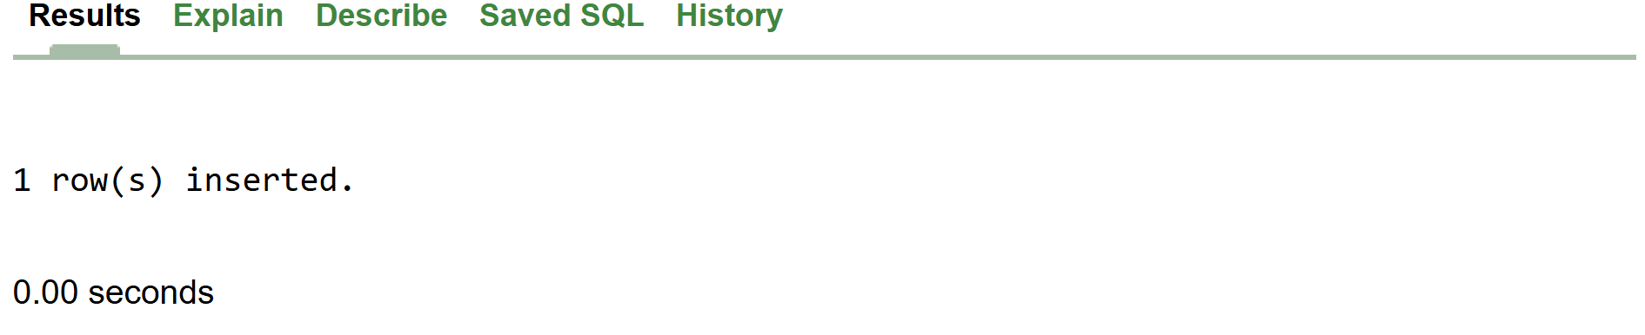

Single statement:
DESCRIBE TUF_STUDENTS
INSERT INTO TUF_STUDENTS
VALUES ('2023-BS-AI-017', 'HAMNA', TO_DATE('01-08-2023', 'DD-MM-YYYY'), '+923669994996', '33100-5555092-0');

Dual statement:
INSERT ALL
INTO TUF_STUDENTS
VALUES ('2023-BS-AI-020', 'MISHAL', TO_DATE('22-08-2023', 'DD-MM-YYYY'), '+923998865409', '33100-59875347-0')
INTO TUF_STUDENTS
VALUES ('2023-BS-AI-021', 'YUMNA', TO_DATE('24-08-2023', 'DD-MM-YYYY'), '+923998654408', '33100-75314579-0')
SELECT * FROM dual;

UPDATE TUF_STUDENTS
SET NAME = 'ABC'

UPDATE TUF_STUDENTS
SET NAME = 'XYZ'
WHERE REGISTRATION = '2023-BS-AI-017';

DELETE TUF_STUDENTS

LAB 4:
TASK # 3:
CREATE TABLE PATIENT (
PATIENT_ID INT PRIMARY KEY,
NAME VARCHAR(100) NOT NULL,
AGE INT,
DISEASE VARCHAR(100) UNIQUE
);

DESCRIBE PATIENT

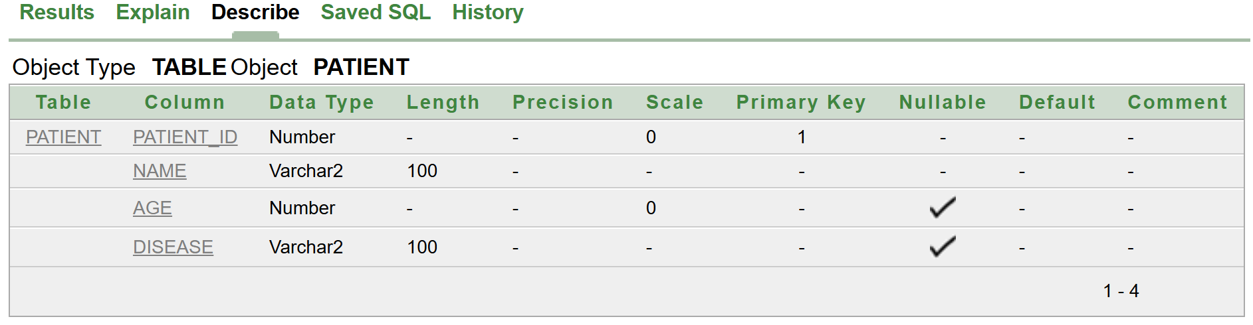

ALTER TABLE PATIENT
ADD DOCTOR_NAME VARCHAR(100);

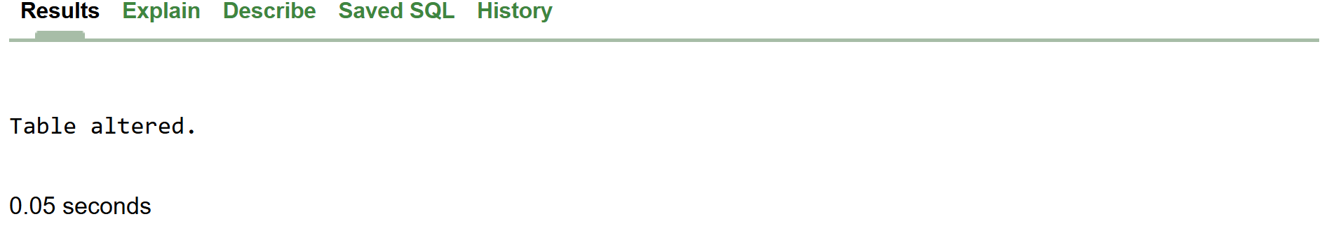
ALTER TABLE PATIENT
RENAME TO PATIENT_RECORDS;

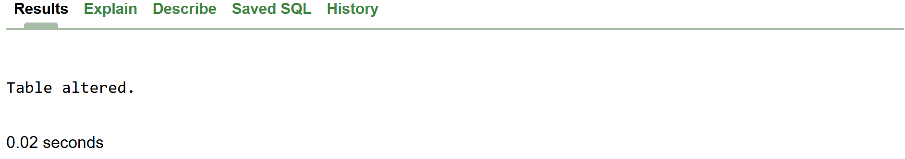

DESCRIBE PATIENT_RECORDS
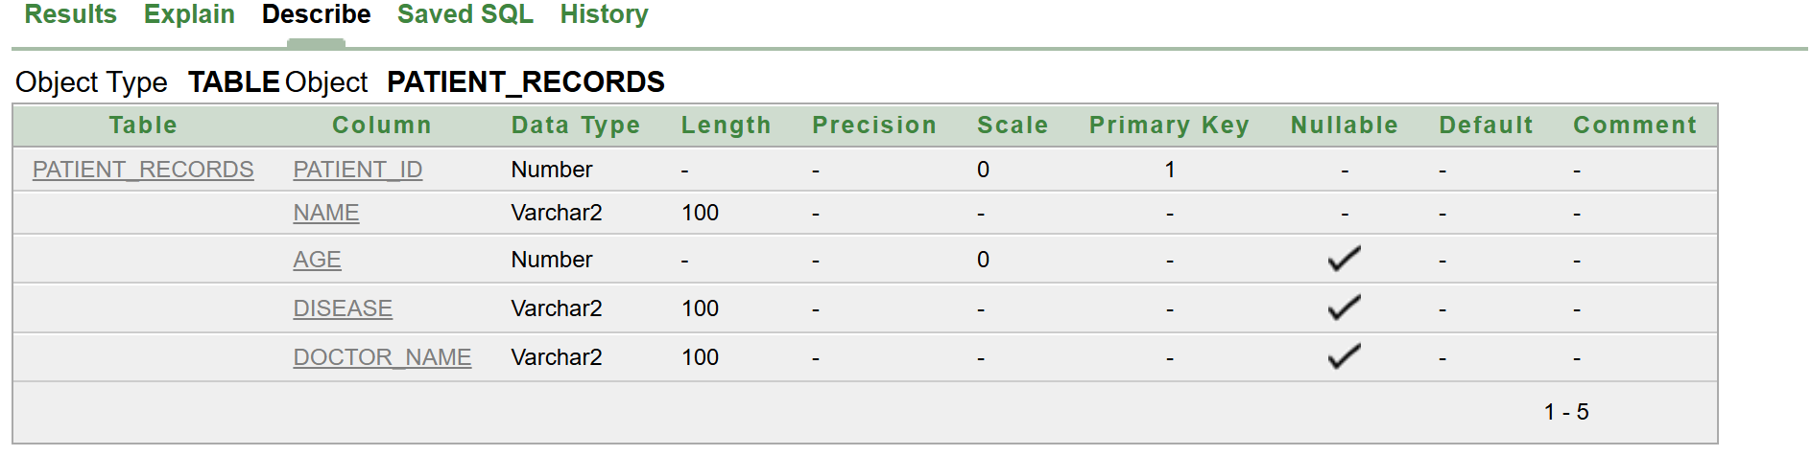

INSERT ALL
INTO PATIENT_RECORDS
VALUES ('001','FATIMA',18

LAB 5:
Task # 1

Query:
SELECT *FROM employees

Result:

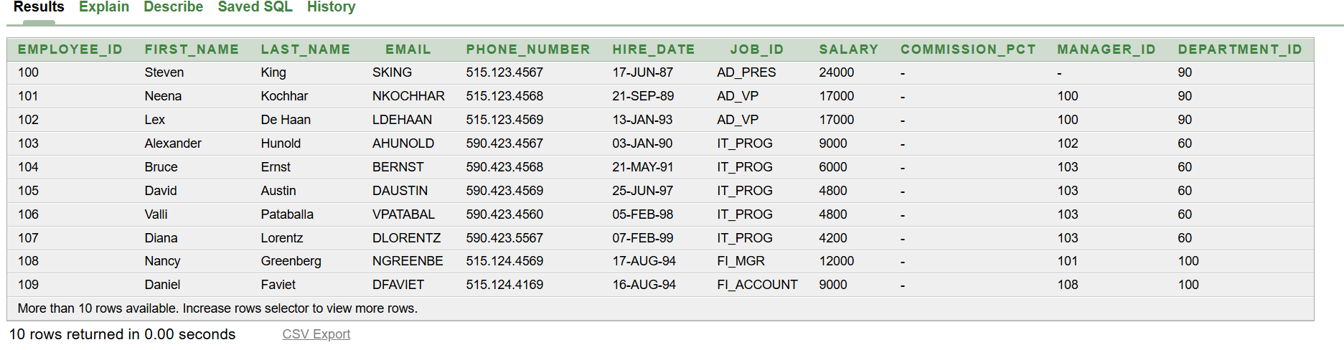

Query:
For specific number of columns:
SELECT EMPLOYEE_ID, LAST_NAME FROM employees
Result:
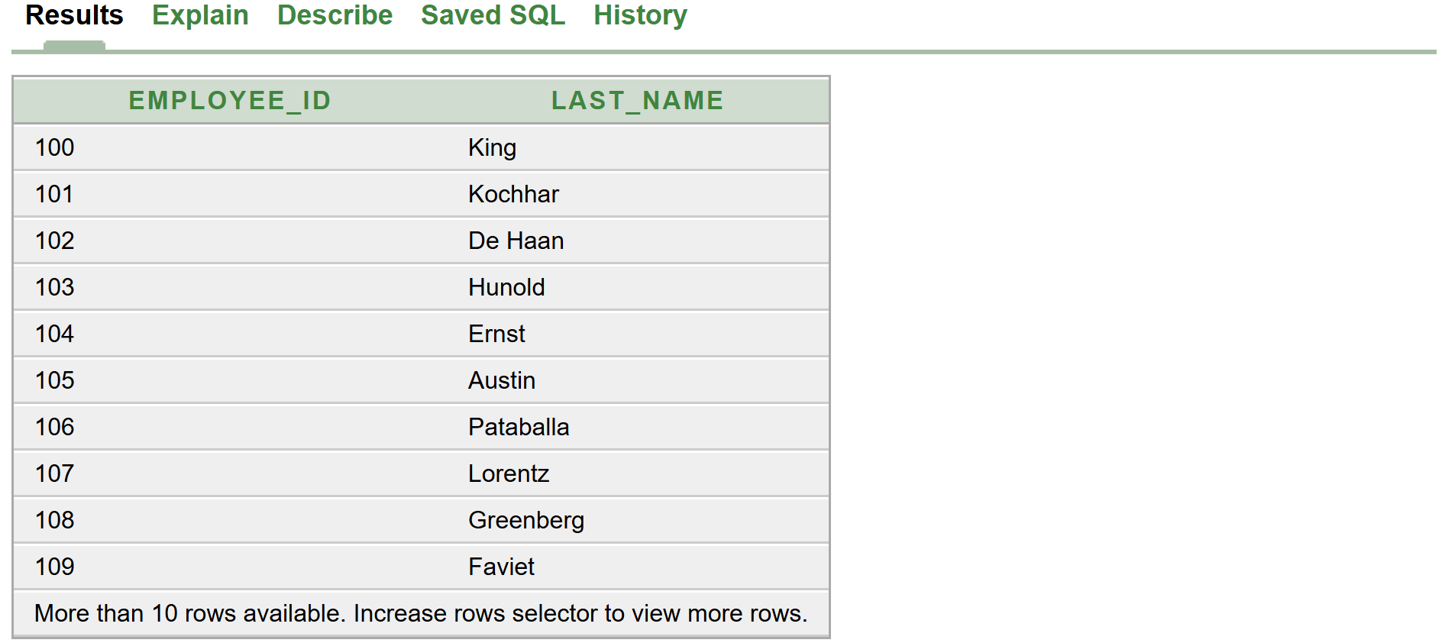

Query:
SELECT DEPARTMENT_ID FROM employees
WHERE DEPARTMENT_ID = 90;
Result:

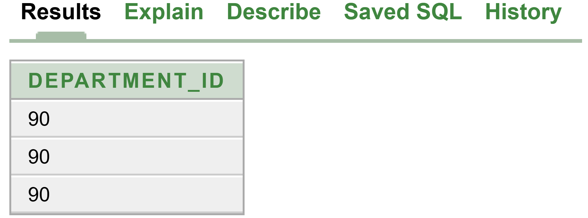

SELECT DEPARTMENT_ID FROM employees
WHERE LAST_NAME=grant;

SELECT DEPARTMENT_ID FROM employees
WHERE SALARY>20000;
Result:
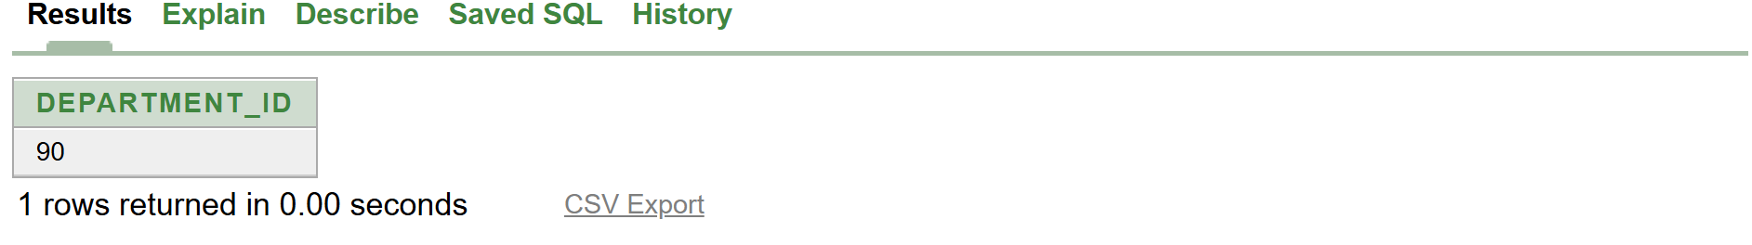
WHERE CLAUSE CAN’T COME BEFORE TABLE

SELECT EMPLOYEE_ID, FIRST_NAME, DEPARTMENT_ID
FROM employees
WHERE JOB_ID = 'IT_PROG';
Result:
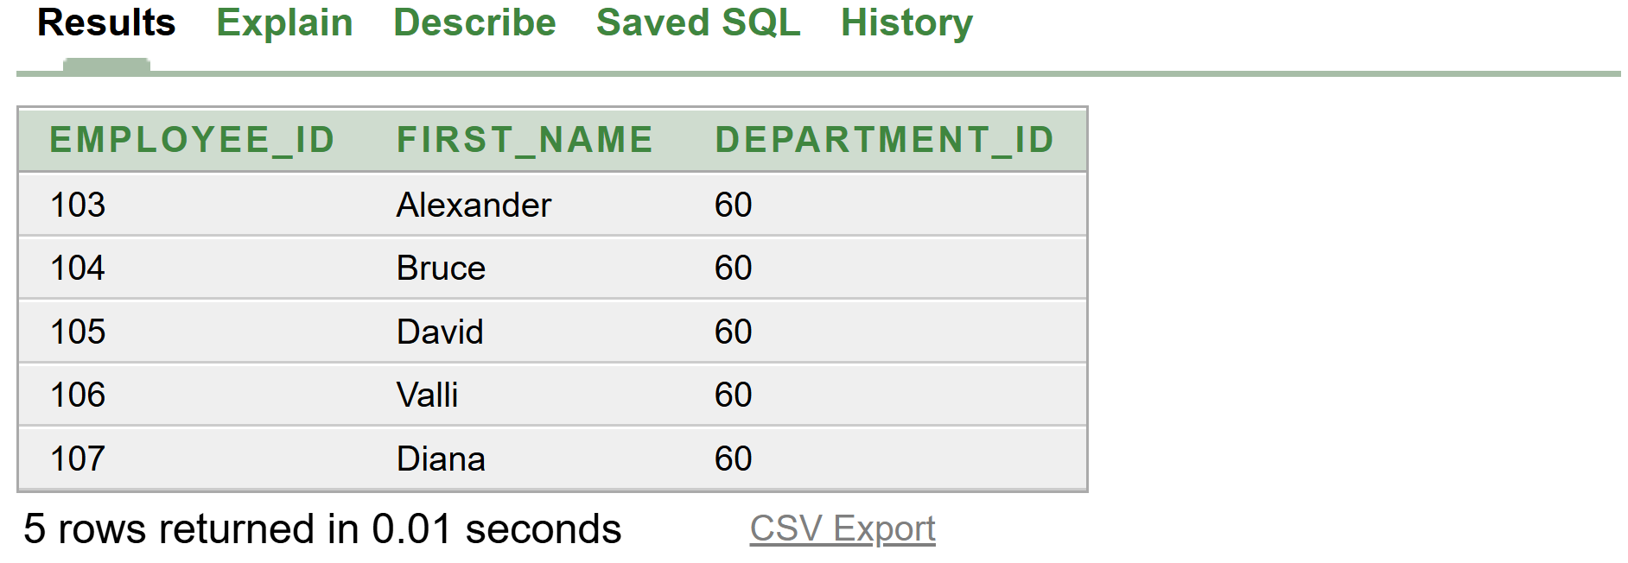

SELECT LAST_NAME, SALARY
FROM employees
WHERE SALARY BETWEEN 2500 AND 3500;
Result:
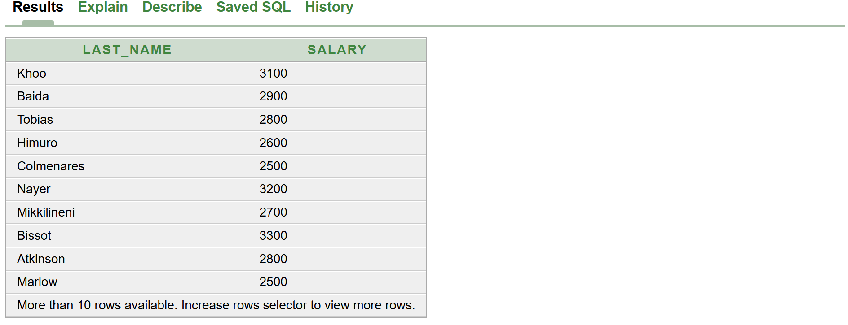

SELECT LAST_NAME, SALARY
FROM employees
WHERE manager_id IN (100,102,103);
Result:
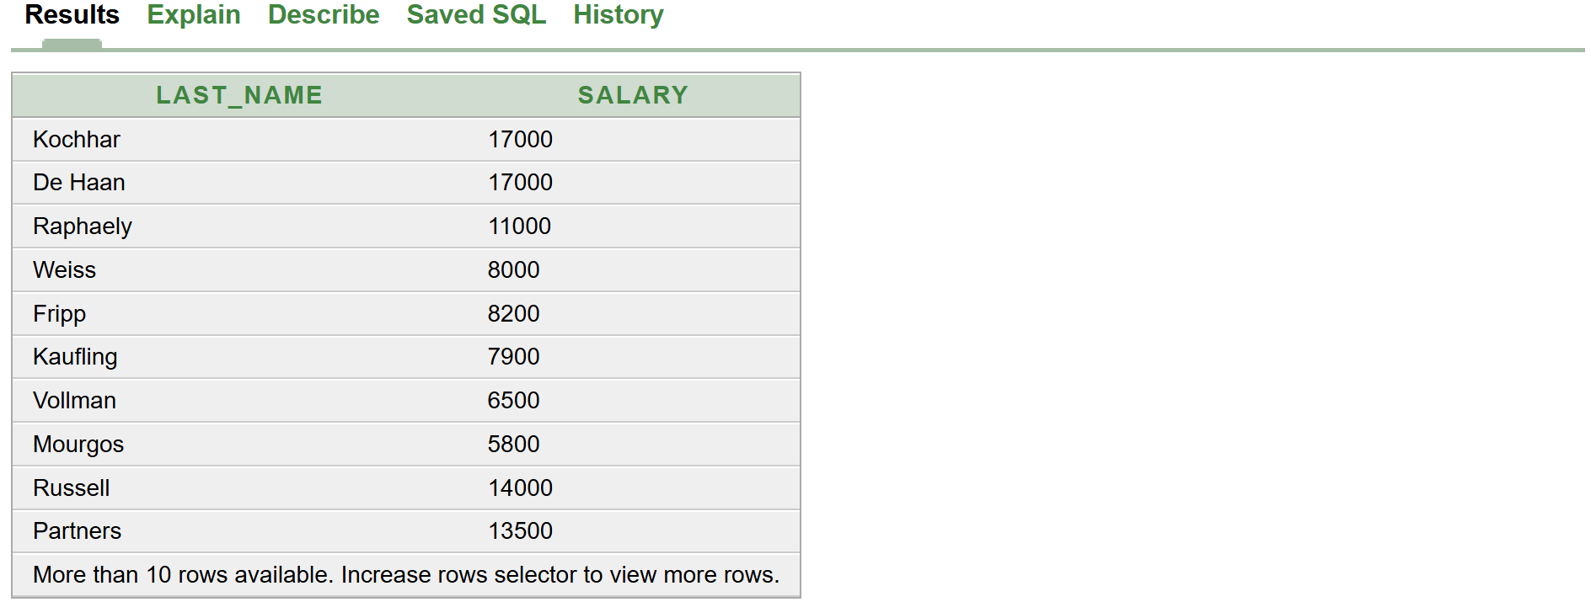

SELECT LAST_NAME, SALARY
FROM employees
WHERE SALARY IN (10000,20000,30000);
Result:

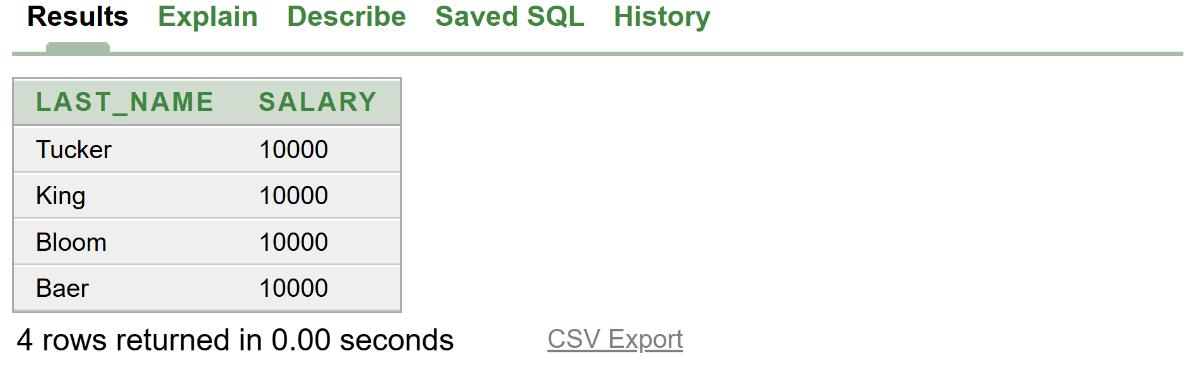

SELECT FIRST_NAME
FROM employees
WHERE FIRST_NAME LIKE 'S%';

SELECT FIRST_NAME
FROM employees
WHERE FIRST_NAME LIKE '_o%';
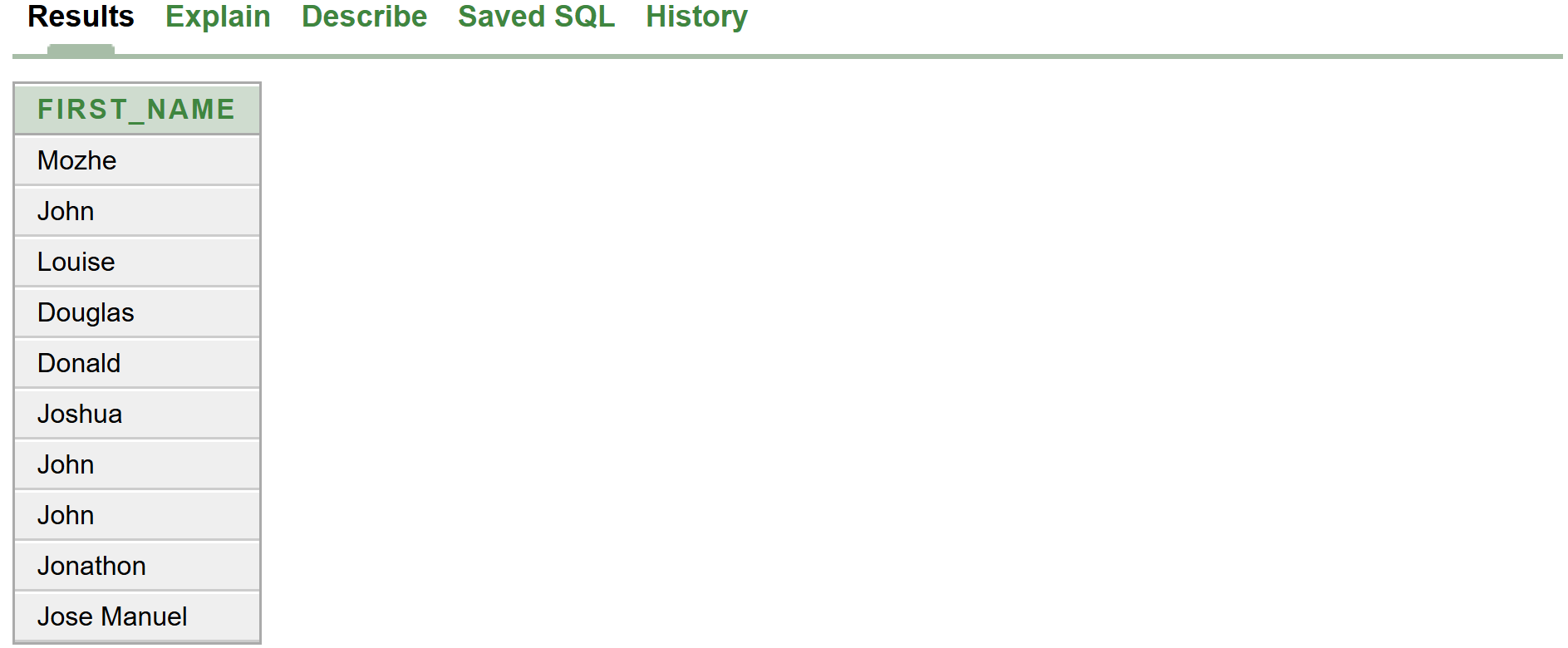

SELECT LAST_NAME, manager_id
FROM employees
WHERE manager_ID IS NULL;
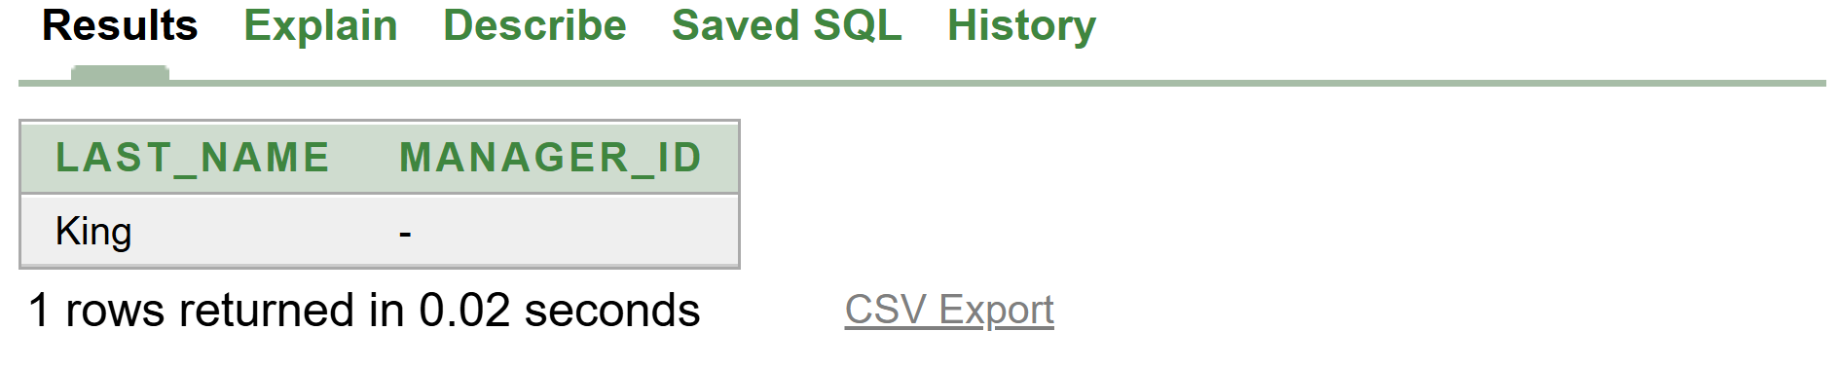

SELECT LAST_NAME, manager_id
FROM employees
WHERE COMMISSION_PCT IS NULL;
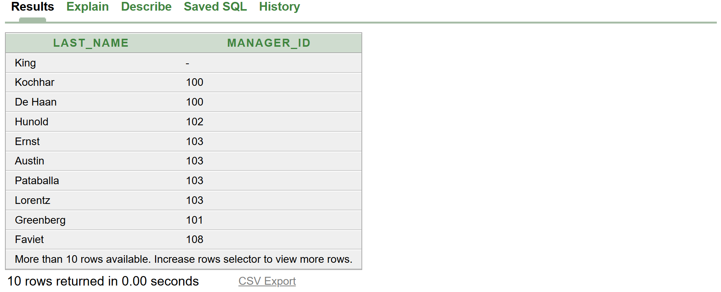

SELECT MANAGER_ID
FROM employees
WHERE HIRE_DATE BETWEEN TO_DATE('21-SEP-89', 'DD-MON-YY')
AND TO_DATE('16-AUG-94', 'DD-MON-YY');

SELECT FIRST_NAME
FROM employees
WHERE LAST_NAME IN ('Jake', 'Lee', 'Kumar');

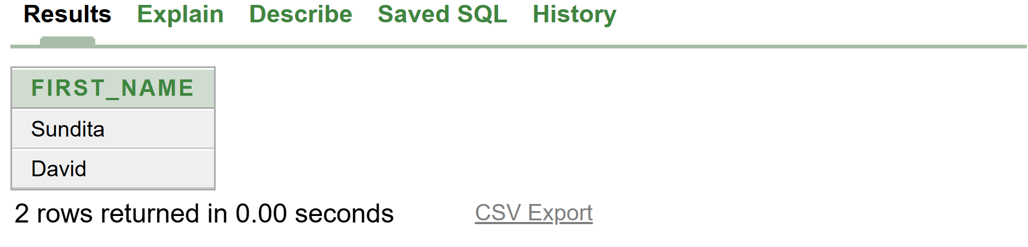

SELECT employee_id, last_name, JOB_ID, salary
FROM employees
WHERE salary >=10000
AND JOB_ID Like '%MAN%';
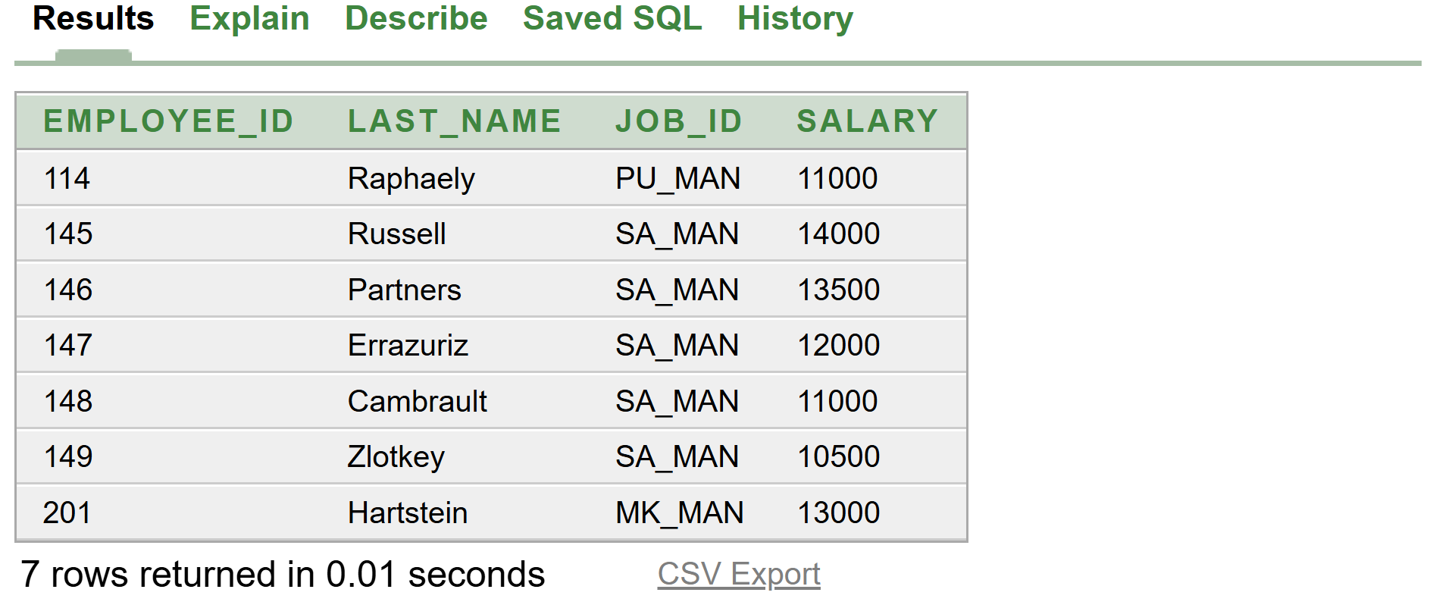

SELECT employee_id
FROM employees
WHERE SALARY > 200
AND JOB_ID LIKE'%IT_PROG%';

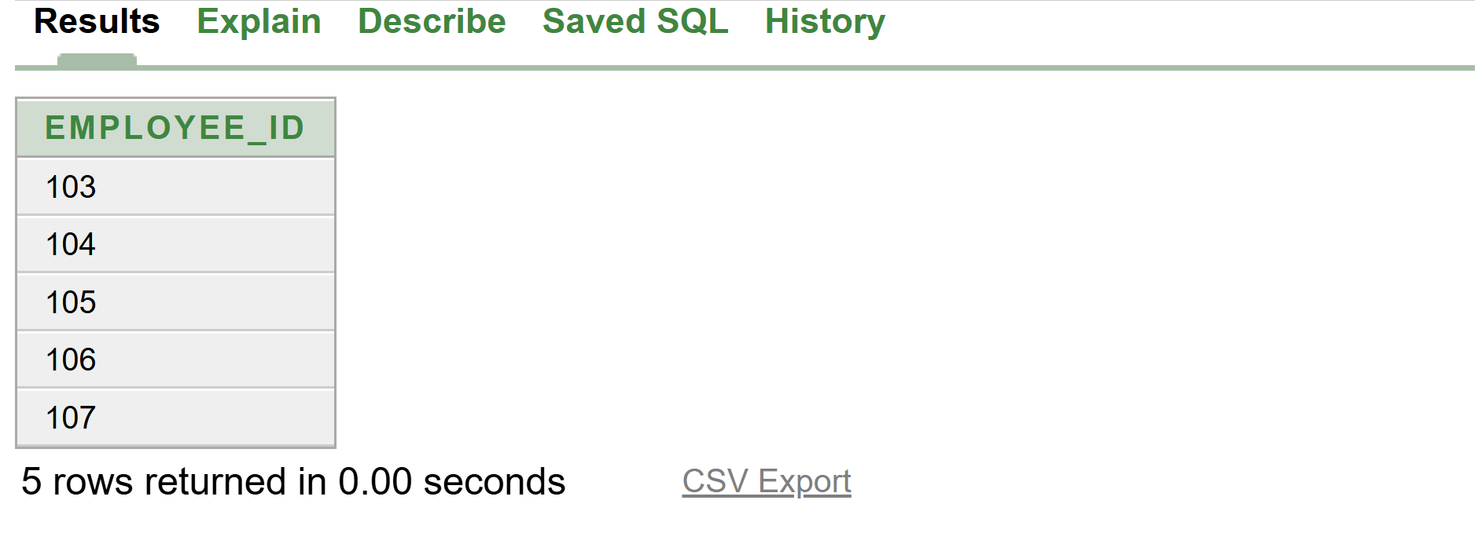

SELECT employee_id
FROM employees
WHERE SALARY > 200
OR JOB_ID LIKE'%IT_PROG%';

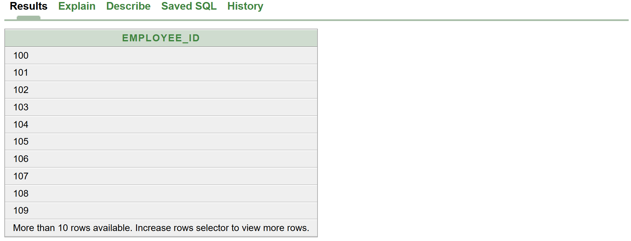

SELECT LAST_NAME, JOB_ID
FROM employees
WHERE JOB_ID
NOT IN ('IT_PROG','ST_CLEAR','SA_REP');

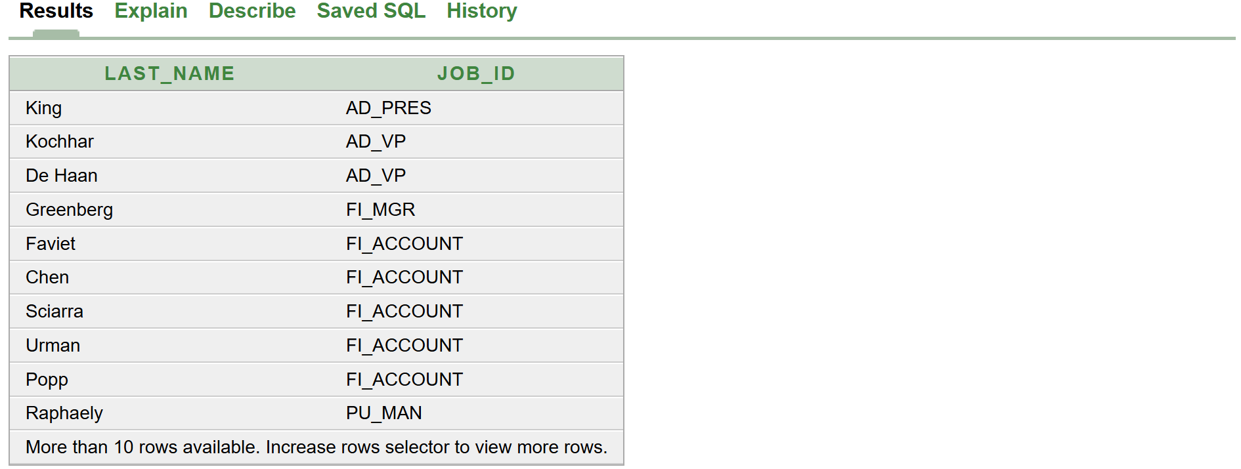

SELECT employee_id, last_name, JOB_ID, salary
FROM employees
WHERE JOB_ID Like '%VP%';

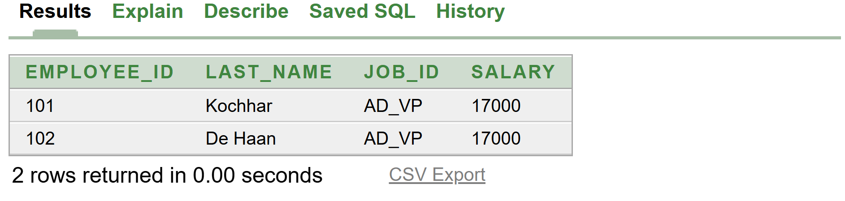

SELECT LAST_NAME,JOB_ID,SALARY
FROM employees
WHERE JOB_ID Like 'SA_REP'
OR JOB_ID = 'AD_PRES'
AND SALARY > 15000;
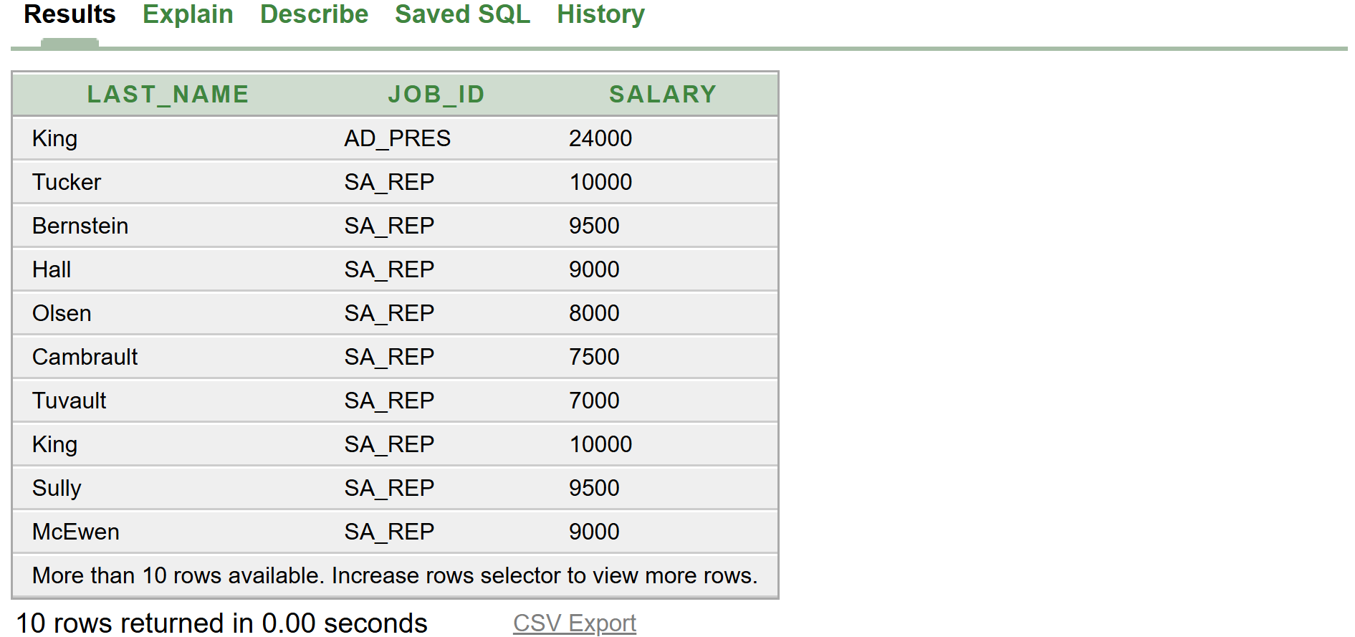

SELECT LAST_NAME,JOB_ID,SALARY
FROM employees
WHERE (JOB_ID Like 'SA_REP'
OR JOB_ID = 'AD_PRES')
AND SALARY > 15000;

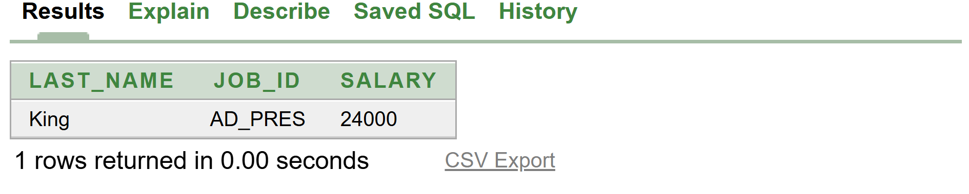

SELECT LAST_NAME, JOB_ID, DEPARTMENT_ID, HIRE_DATE
FROM employees
ORDER BY SALARY DESC
